A Project Report on

PAGERANK ALGORITHM AND GOOGLE SEARCH ENGINE
Submitted by
Group – 12

MITHIN DEV A CB.EN.U4AIE22132
G S J SUCHARAN CB.EN.U4AIE22119
J VIKASH CB.EN.U4AIE22156
N CHARISH YADAV CB.EN.U4AIE22142

As a part of the subject

MATHEMATICS FOR COMPUTING - II



Centre for Computational Engineering and Networking
AMRITA SCHOOL OF ENGINEERING
AMRITA VISHWA VIDYAPEETHAM

COIMBATORE - 641 112 (INDIA)
February - 2023

DECLARATION

We hereby declare that the project work entitled, “PageRank Algorithm and Google Search Engine” submitted to the Department of CEN is a record of the original work done by us under the guidance of Dr K.P. Soman, Amrita Vishwa and that it has not been performed for the award of any Degree/Diploma/Associate Fellowship/Fellowship and similar titles if any. The results embodied in this thesis have not been submitted to any other University or Institute for the award of any degree or diploma.

MITHIN DEV A CB.EN.U4AIE22132

G S J SUCHARAN CB.EN.U4AIE22119

J VIKASH CB.EN.U4AIE22156

N CHARISH YADAV CB.EN.U4AIE22142

Place: Ettimadai
Date: 28-05-2023

Table of Contents

TABLE OF FIGURES 4
ACKNOWLEDGEMENT 5
ABSTRACT 6
CHAPTER – 1 7
1. INTRODUCTION: 7
1.1 Introduction to Google Search Engine: 7
1.2 Three Stages of Google Search: 7
1.3 Introduction to PageRank Algorithm: 8
1.4 History of the Page Rank: 8
CHAPTER -2 8
2. MATHEMATICAL PRINCIPLES BEHIND PAGE RANK: 8
2.1 Markov Chains: 9
2.2 Stochastic Matrix: 9
2.3 Eigenvector centrality: 10
2.4 Damping factor: 10
2.5 Dangling nodes: 11
2.6 Google Matrix: 11
2.7 Adjacency Matrix: 12
2.7.1 How to Create Adjacency Matrix: 12
2.8 Power Method: 13
2.9 Why Page Rank Still Matters in 2023? 13
CHAPTER-3 14
3. CODING & CONCLUSION: 14
3.1 CODING: 14
3.1.1 CODE-PAGERANK: 14
3.1.2 CODE-PAGERANK EIGEN: 15
3.2 CONCLUSION: 15
REFERENCES 15

TABLE OF FIGURES

Figure 1 Markov chains 9

Figure 2 Stochastic Matrix 10

Figure 3 Formula with Damping factor 11

Figure 4 Dangling node 11

Figure 5 Representation of the Adjacency matrix 13

ACKNOWLEDGEMENT

The successful completion of this project would not have been possible without the support and guidance of several individuals and organizations. We express our sincere gratitude to AMRITA VISHWA VIDYAPEETHAM, who provided us with the resources and facilities necessary to carry out this project.

We would like to express our special thanks of gratitude to our teacher (DR K.P. SOMAN) who gave us the golden opportunity to do this wonderful project on the topic (PageRank Algorithm and google Search Engine), which also helped us in doing a lot of research and we came to know about so many new things. We are thankful for the opportunity given.

Additionally, we would like to acknowledge the efforts of our project team members, who worked tirelessly to bring this project to fruition. Their hard work and dedication were critical to our success.

Finally, we would like to thank all the stakeholders who provided support in various ways. Your contributions have been instrumental in making this project a reality.

We are truly grateful for all the support received, and we hope that this project will serve as a testament to the positive impact of collaboration and teamwork.

ABSTRACT

This report provides an in-depth exploration of the PageRank algorithm and its influence on the Google search engine. It introduces the three stages of Google search: crawling, indexing, and serving search results. Within this context, the PageRank algorithm is discussed, including its early stages of development and its ongoing relevance.

The concept of eigen vector centrality is also examined as an alternative measure of importance for web pages. Eigen vector centrality offers a different perspective on ranking web pages by considering both the number and quality of incoming links.

The report further covers the technical aspects of the PageRank algorithm implementation, including the use of Markov chains, stochastic matrices, and the damping factor. It explains the significance of dangling nodes and the creation of adjacency matrices.

Additionally, the report includes practical code examples in MATLAB, demonstrating the implementation of the PageRank algorithm and the calculation of eigenvector centrality.

In conclusion, this report offers a comprehensive overview of the PageRank algorithm and its role in the Google search engine. It explores the key concepts and components of the algorithm, including Markov chain, stochastic matrices, damping factor, and adjacency matrices. The report also provides practical insights through the MATLAB code snippets, enabling readers to understand the algorithm's implementation process. Overall, this report serves as a valuable resource for anyone seeking to comprehend and apply the PageRank algorithm in the context of web search and information retrieval.

CHAPTER – 1

INTRODUCTION:

1.1 Introduction to Google Search Engine:

The Google search engine, introduced in 1998, has transformed the way we find information online. With advanced algorithms and constant indexing, Google delivers highly accurate and relevant search results in seconds. Its user-friendly interface and diverse services, such as image and news search, make it an indispensable tool. Google's commitment to quality is evident through algorithm updates and efforts to combat spam. Innovative features like voice search and knowledge panels enhance the search experience. Widely adopted by users and businesses, Google continues to be the go-to resource for accessing reliable and comprehensive information. [1]

1.2 Three Stages of Google Search:

The Google search process consists of three key stages: crawling, indexing, and serving search results. Here's a brief explanation of each stage:
Crawling: In this stage, Google's automated software, known as crawlers or spiders, traverse the web by following links from one webpage to another. These crawlers start from a set of seed URLs and systematically explore the interconnected web, discovering new pages and revisiting previously indexed ones. During the crawling process, the crawlers collect information about each webpage, including its URL, content, and links to other pages.

Indexing: Once the crawlers fetch the webpages, the next stage is indexing. During indexing, the collected information is analyzed and organized to create a searchable index. Google's indexing system parses the webpage content, extracts relevant metadata, and assigns it to various indexed databases. This process enables Google to efficiently retrieve and rank pages based on user queries. The index includes a wide range of data, such as keywords, page titles, headers, and the text within the page.

Serving Search Results: When a user enters a search query, Google's search engine utilizes the indexed data to determine the most relevant web pages. The search engine evaluates factors like keyword relevance, page quality, user location, and personalization signals to generate a list of search results. These results are presented to the user in a ranked order, with the most relevant and authoritative pages typically appearing at the top. Google's ranking algorithms, such as PageRank and other sophisticated techniques, determine the order in which search results are displayed to users.

Overall, the three stages of crawling, indexing, and serving search results are integral to Google's ability to deliver fast and accurate search experiences, enabling users to find relevant information from the vast expanse of the World Wide Web.

1.3 Introduction to PageRank Algorithm:

The PageRank algorithm, developed by Larry Page and Sergey Brin at Stanford University in the late 1990s, revolutionized web search by introducing a novel approach to ranking web pages. PageRank assigns a numerical score to web pages based on their importance and relevance within the overall network of interconnected pages on the internet. This algorithm played a pivotal role in the success of the Google search engine and continues to be a fundamental component of modern search algorithms. [2]

1.4 History of the Page Rank:

PageRank, developed by Larry Page and Sergey Brin the founders of Google at Stanford University in the late 1990s, revolutionized web search by introducing a groundbreaking algorithm for ranking web pages. Initially conceived as a way to assess the importance and authority of web pages based on incoming links, PageRank became a fundamental component of Google's search engine, propelling its rise to dominance. The algorithm's ability to analyze the interconnectedness of web pages rather than relying solely on keyword matching was a breakthrough in search technology, paving the way for more relevant and accurate search results.

CHAPTER -2

MATHEMATICAL PRINCIPLES BEHIND PAGE RANK:

A general case in which the Page rank of any page u can be found is,
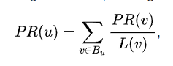
The PageRank score for page u is determined by the PageRank scores for each page v in the set B_{u} (the set of all pages connecting to page u), divided by the quantity L(v) of links from page v.

So first let us list out what are all the mathematical principles lie behind Page Rank,
- Markov Chains
- Stochastic Matrix
- Eigenvector centrality
- Damping Factor
- Dangling Nodes
- Google Matrix
- Adjacency Matrix
- Power Method

2.1 Markov Chains:

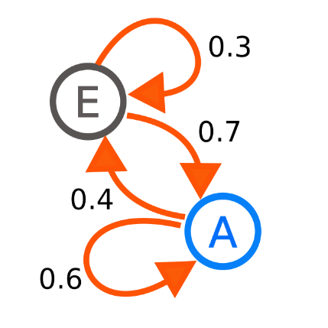
Markov chains are used to model the transition probabilities between web pages. Markov chains are mathematical models that describe a sequence of events where the future state depends solely on the current state. In the case of PageRank, web pages are considered states, and the links between them represent the transitions. [3]
Figure 1 Markov chains
A non-negative n x n matrix with each row adding up to 1 is known as a row-stochastic matrix [4]. Its usage in Markov chains makes it significant in this context. A stochastic process called a Markov chain satisfies the memoryless Markov property, which states that the probability of future behaviour is unrelated to past behaviour.

2.2 Stochastic Matrix:

A stochastic matrix is a square matrix whose elements each indicate the likelihood that a web page will change states. The source websites are represented by the matrix's rows, while the destination web pages are represented by the matrix's columns [5]. Most of the time, the matrix's entries are non-negative and add up to 1. It is also known as a Markov matrix, a Markov transition matrix, or a probability matrix. The matrix's components must all be real numbers inside the restricted range [0, 1].

There are many types of stochastic matrices,
- A right stochastic matrix is a real square matrix, with each row summing to 1.
- A left stochastic matrix is a real square matrix, with each column summing to 1.
- A doubly stochastic matrix is a square matrix of nonnegative real numbers with each row and column summing to 1.

If the probability of moving from i to j in a one-time step is Pr(j|i) = Pi,j, the stochastic matrix P is given by using Pi,j as the i-th row and j-th column element,

Example:

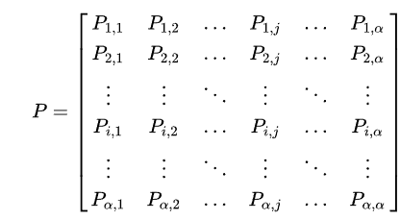
Figure 2 Stochastic Matrix
Since the total of transition probability from a state i to all other states must be 1,
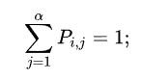
Thus, this matrix is a right stochastic matrix.

2.3 Eigenvector centrality:

Eigenvector centrality is a measure of node importance in a network, including the analysis of web graphs. It quantifies the influence and significance of a node based on its connections to other important nodes within the network. In simpler terms, eigenvector centrality identifies nodes that are connected to other influential nodes, suggesting their own importance.
The concept behind eigenvector centrality is that the importance of a node is not solely determined by the number of connections it has, but also by the quality and importance of those connections. Nodes connected to other highly central nodes receive higher eigenvector centrality scores.

2.4 Damping factor:

According to the PageRank hypothesis, a hypothetical surfer who randomly clicks on links will soon stop doing so. A damping factor is the likelihood that the individual will keep following connections at any given point. Instead, there is a 1-d chance that they will jump to any random page. Although different damping values have been evaluated in various research, it is typically anticipated that the damping factor will be fixed at about 0.85.

This component is added to the product of the damping factor and the sum of the incoming PageRank scores after the damping factor is subtracted from 1 (and in some implementations of the algorithm, the result is divided by the number of pages (N) in the collection).
That is,

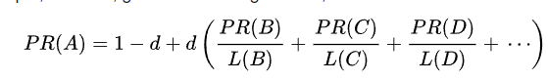
Figure 3 Formula with Damping factor

2.5 Dangling nodes:

Dangling nodes refer to web pages that have no outgoing links. These pages do not provide any direct pathway to other pages within the web graph. Dangling nodes can arise due to various reasons, such as dead-end pages, pages with broken links, or pages that intentionally have no outgoing links. A dangling link is a hyperlink pointing to dangling nodes. Therefore, dangling nodes keep losing their ranks and thus the sum of ranks in the overall system keep decreasing. [6]
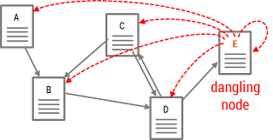
Figure 4 Dangling node
However, the dangling links problem can be easily solved by adding virtual links from dangling nodes to all web pages.

2.6 Google Matrix:

The PageRank algorithm of Google uses a specific stochastic matrix called a "Google matrix." The edges of the matrix, which form a graph, stand in for linkages between pages. The power approach can then be used to iteratively calculate each page's PageRank from the Google matrix. [7]

Then the final Google matrix G can be expressed by S as:
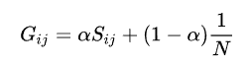

By the construction, the sum of all non-negative elements inside each matrix column is equal to unity. The numerical coefficient is known as a damping factor.

2.7 Adjacency Matrix:

The adjacency matrix is a fundamental component in the calculation of PageRank scores and understanding of the PageRank algorithm. It represents the connectivity structure of a web graph by indicating which web pages are linked to each other.

The adjacency matrix is a square matrix where the rows and columns represent web pages, and the entries indicate whether a link exists between two pages. A value of 1 in the matrix indicates a link, while a value of 0 indicates no link. The adjacency matrix provides a binary representation of the web graph's connectivity. [8]

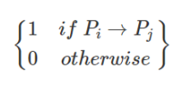
If the simple graph has no self-loops, Then the vertex matrix should have 0s in the
diagonal. It is symmetric for the undirected graph. The connection matrix is
considered as a square array where each row represents the out-nodes of a graph
and each column represents the in-nodes of a graph. Entry 1 represents that there is
an edge between two nodes.

The adjacency matrix for an undirected graph is symmetric. This indicates the
value in the ith row and jth column is identical with the value in the jth row and ith
column.

2.7.1 How to Create Adjacency Matrix:

To create an adjacency matrix for the PageRank algorithm, you would follow these steps:

Identify the web pages: Determine the set of web pages that you want to include in your analysis.

Define the matrix dimensions: Count the total number of web pages and assign a unique index to each page. This will determine the dimensions of your adjacency matrix, which will be n x n, where n is the total number of web pages.

Initialize the matrix: Create an n x n matrix filled with zeros to represent the initial adjacency matrix.

Analyze the links: Examine the links between web pages and identify the relationships. For each link from page i to page j, you will update the corresponding entry in the adjacency matrix with a value of 1.

Update the matrix entries: Traverse through each link and update the corresponding entry in the adjacency matrix with a value of 1.
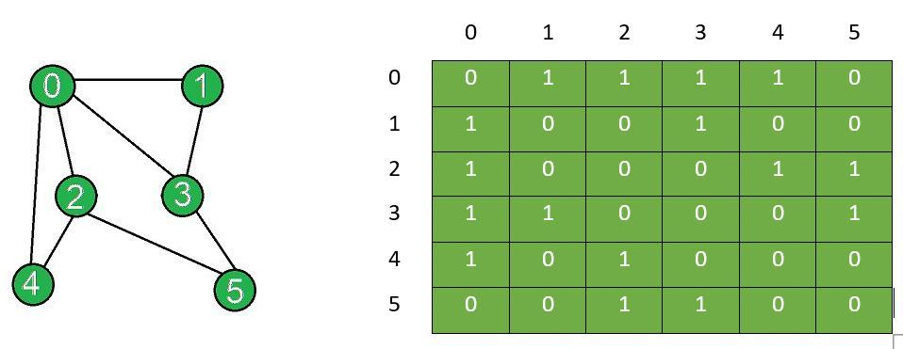
Figure 5 Representation of the Adjacency matrix

Imagine this table as a matrix, a value of 1 in the (i, j) entry indicates that there is a link from the i-th web page to the j-th web page.

Once you have created the adjacency matrix, you can use it as input for further calculations in the PageRank algorithm, such as constructing the stochastic matrix and iteratively computing the PageRank scores.

2.8 Power Method:

The power method is based on the principle that in an iterative process, repeatedly multiplying a vector by a matrix will eventually converge to the dominant eigenvector of the matrix. In the context of the PageRank algorithm, the dominant eigenvector corresponds to the importance scores or PageRank values of the web pages.

It's worth noting that the power method is an approximation algorithm and may require multiple iterations to converge to a satisfactory solution. However, it is computationally efficient and widely used in practice to calculate PageRank scores and other applications involving dominant eigenvector estimation.

Why Page Rank Still Matters in 2023?

PageRank remains highly relevant in 2023 due to its central role in Google's search algorithm and its impact on web search and related fields. As a fundamental component of search ranking, PageRank helps determine the authority and relevance of web pages, ensuring that users receive reliable and valuable search results. It serves as a measure of quality and trustworthiness, aiding in the fight against spam and providing users with high-quality information. Moreover, PageRank's influence extends beyond search engine optimization, enabling effective backlink analysis and contributing to research in graph theory, network analysis, and information retrieval. By facilitating the analysis of web graph structure and connectivity, PageRank continues to shape our understanding of the internet landscape. Overall, PageRank's enduring relevance lies in its integral role in search algorithms, its assessment of page quality, and its impact on research and analysis in various domains.

CHAPTER-3

CODING & CONCLUSION:

CODING:

CODE-PAGERANK:

clc;clear all;

%% Adjacency Matrix
A = [...
0 1 1 1 0;
1 0 1 0 1;
0 0 0 1 0;
1 1 1 0 1;
1 0 1 1 0];
r=5;c=5;

q=[];
for i=1:c
sum=0;
for j=1:r
sum=sum+A(j,i);
end
q(i)=sum;
end

%% Probability Matrix
P=[];
for i=1:r
for j=1:c
if(A(i,j)==1)
P(i,j)=1/q(j);
else
P(i,j)=0;
end
end
end
P

%% Power Method
v=[0 1 0 0 0];
% P*v';
% P*(P*v');
k=P*v';
n=1000;
for i=1:(n-1)
k=P*k;
end

%% Google Matrix
% to deal with dangling nodes and loops
S=[]
for i=1:r
for j=1:c
S(i,j)=1/r;
end
end
alpha =0.85 % damping factor
G=alpha*P + (1-alpha)*S;

CODE-PAGERANK EIGEN VECTOR:

% Considering Damping Factor
x1=[1/5 1/5 1/5 1/5 1/5]';

% Dampling Factor is set to 0.85
d=0.85;

% Concatnating Each iteration into the matrix k1
k1=[];

for i=1:20
x1=d*(A*x1)+((1-d)/5);
x1=x1/sum(x1);
k1=[k1 x1];
end
k1

rank2=rankMatrix(x1)

3.2 CONCLUSION:

The PageRank algorithm, developed by Larry Page and Sergey Brin at Google, has transformed the way we search and access information on the web. It introduced a groundbreaking approach to ranking web pages based on importance and relevance. By utilizing mathematical principles like adjacency matrices, Markov chains, and eigenvector centrality, PageRank evaluates the interconnectedness and significance of web pages within the vast web graph. Factors such as incoming links are considered to determine a page's importance, resulting in more accurate search results.

Over time, PageRank has evolved to incorporate refinements like the damping factor, addressing user behavior, and handling dangling nodes. These enhancements have improved the algorithm's effectiveness in assessing page authority. PageRank's impact extends beyond Google, with its principles being widely adopted in various fields such as network analysis and recommendation systems.

As the internet continues to evolve, PageRank remains a fundamental component of search engine technology. It adapts to the dynamic web landscape, ensuring relevant and authoritative pages are ranked higher. The influence of PageRank is evident in how we search and access information online, making it a crucial aspect of navigating the ever-expanding digital world.

REFERENCES

[1] | "wikipedia," [Online]. Available: https://en.wikipedia.org/wiki/PageRank#:~:text=PageRank%20(PR)%20is%20an%20algorithm,the%20importance%20of%20website%20pages..
[2] | "pagerank wiki," [Online]. Available: https://en.wikipedia.org/wiki/PageRank#:~:text=PageRank%20(PR)%20is%20an%20algorithm,the%20importance%20of%20website%20pages..
[3] | "markov wiki," [Online]. Available: https://en.wikipedia.org/wiki/Markov_chain#:~:text=A%20Markov%20chain%20or%20Markov,the%20state%20of%20affairs%20now.%22.
[4] | "markov image," [Online]. Available: https://upload.wikimedia.org/wikipedia/commons/thumb/2/2b/Markovkate_01.svg/640px-Markovkate_01.svg.png.
[5] | "stochastic wiki," [Online]. Available: https://en.wikipedia.org/wiki/Stochastic_matrix#:~:text=In%20mathematics%2C%20a%20stochastic%20matrix,substitution%20matrix%2C%20or%20Markov%20matrix..
[6] | "dangling nodes," [Online]. Available: https://changuk.github.io/assets/img/99d73f15862f603f64fba5797aa178d7c1f3b26723800852c090535407c79fcf.png.
[7] | "google matrix," [Online]. Available: https://en.wikipedia.org/wiki/Google_matrix.
[8] | "adjacency matrix," [Online]. Available: https://media.geeksforgeeks.org/wp-content/uploads/20200604170842/add-and-remove-edge-in-adjacency-matrix-representation-final2.jpg.

